**LOAD VERSUS TEMPERATURE DEPENDENCE**

**INTRODUCTION**

The load consumption is a dependent variable affected by numerous factors at the time, HVAC device usage being one of them. HVAC device (ACs, Fans and heaters) depends on the temperature of the environment in which they are being used. Naturally, in the cold, heating devices are used more, and in the heat, ACs and Fans are used for shorter or longer periods depending on the intensity.

As the cost of electricity generation increases, it is imperative to develop practices that ensure adequate consumption. This will also include effective use of the HVAC devices and an understanding of energy use. Understanding and establishing a relationship between both variables becomes essential if necessary.

**OBJECTIVE**

* Establish the relationship between energy consumption and temperature levels.
* Determine if the relationship between the two variables is sufficient to make predictions.

**SCOPE OF STUDY**

The study is based on the energy consumption of AB at Oba Akran and the weather conditions in Lagos State. Temperature data for Lagos state over a year will be obtained (January 2021- January 2022).

**METHODOLOGY**

In such a relationship (between two variables), the independent variable is temperature, and the dependent variable is energy consumption. A regression analysis and correlation analysis on these variables will help establish the relationship and statistical significance of the relationship between the variables.

For this study, we will employ the following methods:

1. Data collection
2. Data cleaning
3. Data Analysis:

a. Regression Test

b. Correlation Test

4. Result analysis and interpretation

5. Documentation of results

**DATA COLLECTION**

The temperature data was collected from the [NASA Data Access Viewer](https://power.larc.nasa.gov/data-access-viewer/), while a year’s energy consumption data was obtained from company archives.

**DATA CLEANING**

The total system consumption was derived from the data available in the company archives and then merged with temperature data hourly from January 2021 - January 2022.

**DATA ANALYSIS**

**REGRESSION ANALYSIS**

A simple linear regression analysis (only two variables considered) was carried out using the OLS ([Ordinary Least Square](https://www.xlstat.com/en/solutions/features/ordinary-least-squares-regression-ols)) method.



--------------------------------------------------------------------------------------------------------------------------

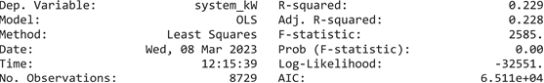

--------------------------------------------------------------------------------------------------------------------------





--------------------------------------------------------------------------------------------------------------------------

--------------------------------------------------------------------------------------------------------------------------





--------------------------------------------------------------------------------------------------------------------------



This summarises a linear regression model with "system_kW" as the dependent variable and "T2M" as the independent variable. The regression equation is given by: system **kW = -57.6225 + 2.7975*T2M.** The coefficient of determination (R-squared) is 0.229, **which means that 22.9% of**

**the variation in system kW can be explained by T2M**. The F-statistic is 2585 with a p-value of 0.00, indicating that the model is significant overall. The coefficient for T2M is 2.7975 with a standard error of 0.055. The t-value for T2M is 50.840, with a p-value of 0.00, indicating that T2M is a significant predictor of system_kW.

The intercept (constant) of the regression line is -57.6225. The omnibus test, which tests for the normality of residuals, has a p-value of 0.00, indicating that the residuals may not be normally distributed. The Durbin-Watson test has a value of 0.182, which indicates that there may be positive autocorrelation present in the residuals. The Jarque-Bera test has a p-value of 2.68e-131, indicating

that the residuals may not be normally distributed or have a constant variance. The condition number is 359, indicating that multicollinearity may be present in the data.

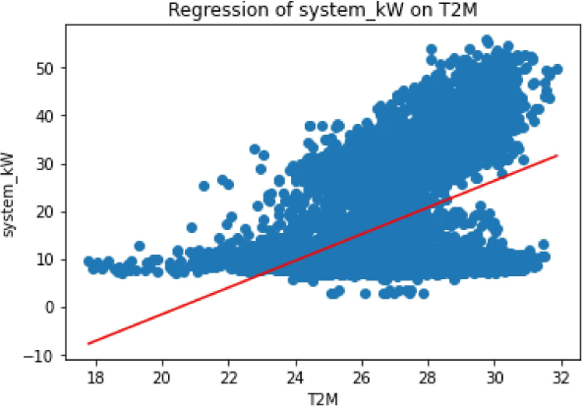

**PEARSONS CORRELATION**

The output indicates that the Pearson correlation coefficient between the "system_kW" and "T2M" variables is 0.478, which is a positive value. **This suggests that there is a positive linear relationship between the two variables. A correlation coefficient of 0.478 indicates that as "T2M" values increase, "system kW" also tends to increase. Conversely, as "T2M" values decrease, "system kW" also tends to decrease. The output also states a positive correlation between the two columns, confirming the finding from the correlation coefficient value.**

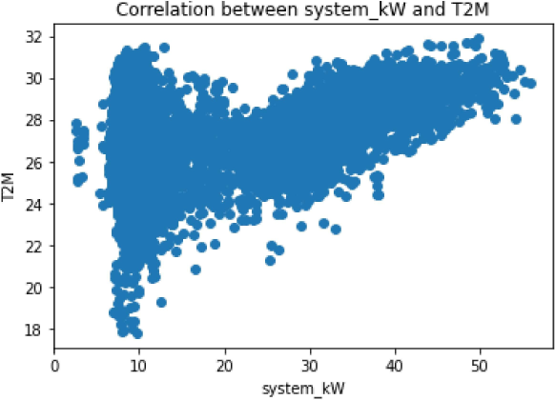

**SPEARMAN’S RANK CORRELATION**

The Spearman's rank correlation coefficient measures the strength and direction of the association between two variables without assuming a linear relationship. In this case, Spearman's rank correlation coefficient is 0.3599, which indicates a moderate positive correlation between the two variables. **This suggests that as one variable increases, the other variable also tends to increase, and vice versa**. The p-value of the correlation coefficient is 2.8494e-265, which is very small, indicating strong evidence against the null hypothesis of no correlation. Therefore, we can conclude that there is a significant correlation between the two variables. Overall, the result suggests that there is a moderate positive association between the two variables being analysed, and this relationship is statistically significant.

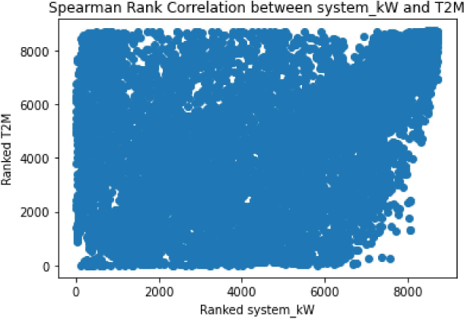

**Summary**

The results of several statistical analyses performed on a dataset containing variables related to system_kW and Temperature. The Pearson correlation coefficient shows a moderate to strong positive correlation between the two variables. The OLS regression output shows that Temperature is a significant predictor of system_kW, and a higher temperature leads to a higher system_kW.